# Seminar Report

On

**OLED**

Submitted in the fulfilment of the requirements

For the Degree of

Bachelor of Technology

In

Electronics &Telecommunication Engineering

**By**

**Krishna Mani Raj (1814110507)**

Under the guidance of

**Prof. Prasad Dhondiram Kadam**

Department of Electronics and Telecommunication Engineering

Bharati Vidyapeeth Deemed University

College of Engineering,

Pune – 411043

Academic Year:2021-22

**Bharati Vidyapeeth Deemed University,**

**College of Engineering, Pune – 4110043**

**BHARATI VIDYAPEETH (DEEMED TO BE UNIVERSITY)**

**COLLEGE OF ENGINEERING, PUNE – 4110043**

**DEPARTMENT OF ELECTRONICS& TELECOMMUNICATION ENGINEERING**

**CERTIFICATE**

Certified that the seminar report entitled, **“OLED”** is a Bonafide work done by **Krishna Mani Raj** (1814110507).In partial fulfillment of the requirements for the award of the degree of Bachelor of Engineering in Electronics and Telecommunication Engineering.

Date:

Prof. Prasad Dhondiram Kadam Prof. D.K Ray

(Project Guide) (Seminar Co-ordinator)

Prof. Dr. S.K Oza

Head of the Department

**ACKNOWLEDGEMENT**

We would like to extend our sincere gratitude to the Principal “**Dr. Vidula Sohoni”**, Head of Department Electronics & Telecommunication, “**Prof. S.K.Oza”,** for nurturing a congenial yet competitive environment, which motivates all the students not only to pursue goals but also to elevate the Humanitarian level.

Inspiration and guidance are invaluable in every aspect of life, which we have received from our respected project guide “**Prof. Prasad Dhondiram Kadam”,** who gave us his careful and ardent guidance because of which we are able to complete this project. More words won’t suffice to express our gratitude to his untiring devotion. He undoubtedly belongs to the members of the artistic gallery who are masters in all aspects.

We would also like to thank all the faculty members who directly or indirectly helped us from time to time with their invaluable inputs.

**Contents**

1. Introduction 4
2. Construction 4
3. Emission Spectrum 9
4. OLED Architectures 10
5. Manufacturing OLED 11
6. Fabrication Methods 11
   1. Physical Vapor Deposition 12
   2. Spin Coating 13
   3. Inkjet Printing 14
   4. Roll to roll Printing 15
   5. Vacuum Sputtering 15
7. Technical Characteristics 16
8. Types of OLED 17
9. Comparison Between LED and OLED 19
10. Advantages of OLED 21
11. Disadvantages 22
12. Application of OLED 23
13. Challenges 24
14. Future Possibilities 24
15. Conclusion 25
16. References 25

**List of Figures**

Figure 1: Basic OLED Structure 4

Figure 2: Basic OLED Working 6

Figure 3: Energy Level Diagram 7

Figure 4: Typical emission spectra of organic materials 9

Figure 5: Transparent OLED structure 10

Figure 6: Physical Vapor Deposition (PVD) in vacuum chamber 12

Figure 7: Spin coating 13

Figure 8: Ink jet printing to pattern polymers (Full Color Applications) 14

Figure 9: Roll to roll printing production of flexible OLED’s 15

|  |  |
| --- | --- |
| Figure 10: OLED Mass Production System  Figure 11: AMOLED | **…………………………………………….** 16  **..……………………………………….....** 17 |
| Figure 12: Structure of Top-emitting OLED | **…………...……………………………..** 18 |
| Figure 13: Foldable OLED | **………………………………………....** 18 |
| Figure 14: White OLED | **………………………………………....** 19 |
| Figure 15: Comparison of LED and OLED | **………………………………………...** 20 |

Figure 16: Comparison of LED and OLED Display 21

Figure 17: Comparison of LCD, LED and OLED displays 22

Figure 18: Applications of OLED 23

Figure 19: Future of OLED 24

# List of Tables

Table 1: Technical Characteristics of OLED’s 16

**ABSTRACT**

### OLED is a solid state device composed of thin films of organic molecules that create light with the application of electricity. OLEDs can provide brighter.crisper displays on electronic devices and use less power than conventional light emitting diodes(LEDs)used today.

### Like an LED, an OLED is a solid state semiconductor device that is 100 to 500 nanometres thick or about 200 times smaller than a human hair.OLEDs can have either two layers or three layers of organic material.

### An OLED consist of the following parts:

### • Subtrate

### • Anode

### • Organic layers

### • Cathode

### OLEDS emit light through a process called electrophosphorescene. Different types of OLEDs are

### • Passive-matrix OLED

### • Active-matrix OLED

### • Transparent OLED

### • Foldable OLED

### • Top-emitting OLED

### • White OLED Applications

### Currently, OLEDs are used in small-screen devices such as cell phones,PDAs and digital cameras. Research and development in the field of OLEDs is proceeding rapidly now and may lead to future applications in heads-up displays ,automotive dash boards etc.

## Introduction

An organic light-emitting diode (OLED) is a light-emitting diode (LED), in which the emissive electroluminescent layer is a film of organic compound that emits light in response to an electric current. OLED’s are used to create digital displays in devices such as [television](https://en.wikipedia.org/wiki/Television_set) screens, computer, portable systems such as mobile phones, [handheld game](https://en.wikipedia.org/wiki/Handheld_game_console) [consoles](https://en.wikipedia.org/wiki/Handheld_game_console) and PDAs. A major area of research is the development of white OLED devices for use in solid-state lighting applications.

OLED display devices use organic carbon-based films, sandwiched together between two charged electrodes. One is a metallic cathode and the other a transparent anode, which is usually glass. OLED displays can use either passive-matrix (PMOLED) or active- matrix (AMOLED) addressing schemes. Active-matrix OLEDs (AMOLED) require a thin- film transistor backplane to switch each individual pixel on or off, but allow for higher resolution and larger display sizes.

An OLED display works without a backlight; thus, it can display deep black levels and can be thinner and lighter than a liquid crystal display (LCD). In low ambient light conditions (such as a dark room), an OLED screen can achieve a higher contrast ratio than an LCD, regardless of whether the LCD uses cold cathode fluorescent lamps or an LED backlight.

## Construction

A typical OLED is composed of a layer of organic materials situated between two electrodes, the anode and cathode, all deposited on a substrate. The organic molecules are electrically conductive as a result of [delocalization](https://en.wikipedia.org/wiki/Delocalized_electron) of [pi electrons](https://en.wikipedia.org/wiki/Pi_electrons) caused by [conjugation](https://en.wikipedia.org/wiki/Conjugated_system) over part or the entire molecule. These materials have conductivity levels ranging from insulators to conductors, and are therefore considered [organic semiconductors](https://en.wikipedia.org/wiki/Organic_semiconductor). The highest occupied and lowest unoccupied molecular orbitals (HOMO and LUMO) of organic semiconductors are analogous to the [valence](https://en.wikipedia.org/wiki/Valence_band) and [conduction](https://en.wikipedia.org/wiki/Conduction_band) bands of inorganic semiconductors.

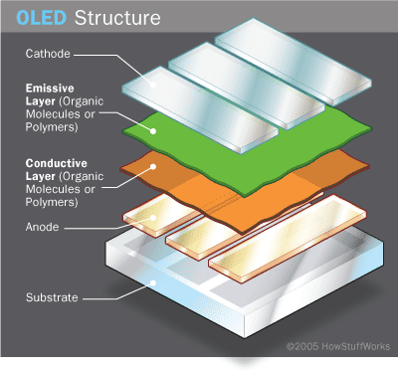

**Figure 1:** Basic OLED structure

Originally, the most basic polymer OLEDs consisted of a single organic layer. One example was the first light-emitting device synthesized by J. H. Burroughes et al., which involved a single layer of poly(p-phenylene vinylene). However multilayer OLEDs can be fabricated with two or more layers in order to improve device efficiency.

As well as conductive properties, different materials may be chosen to aid charge injection at electrodes by providing a more gradual electronic profile, or block a charge from reaching the opposite electrode and being wasted. Many modern OLEDs incorporate a simple bilayer structure, consisting of a conductive layer and an emissive layer.

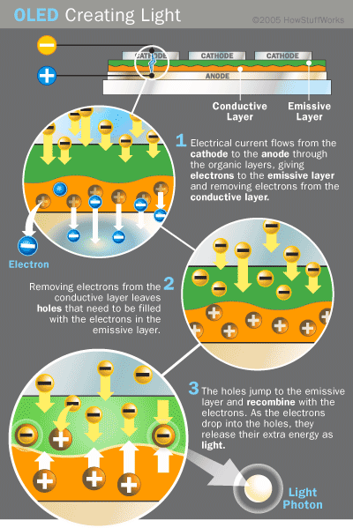

**Figure 2:** Basic OLED working

During operation, a voltage is applied across the OLED such that the anode is positive with respect to the cathode. Anodes are picked based upon the quality of their optical transparency, electrical conductivity, and chemical stability. A current of [electrons](https://en.wikipedia.org/wiki/Electron) flows through the device from cathode to anode, as electrons are injected into the LUMO of the organic layer at the cathode and withdrawn from the HOMO at the anode. This latter process may also be described as the injection of [electron holes](https://en.wikipedia.org/wiki/Electron_hole) into the HOMO. Electrostatic forces bring the electrons and the holes towards each other and they recombine forming an [exciton](https://en.wikipedia.org/wiki/Exciton), a bound state of the electron and hole. This happens closer to the emissive layer, because in organic semiconductors holes are generally more [mobile](https://en.wikipedia.org/wiki/Semiconductor_carrier_mobility) than electrons. The decay of this

excited state results in a relaxation of the energy levels of the electron, accompanied by emission of [radiation](https://en.wikipedia.org/wiki/Radiation) whose [frequency](https://en.wikipedia.org/wiki/Frequency) is in the [visible region](https://en.wikipedia.org/wiki/Visible_spectrum). The frequency of this radiation depends on the [band gap](https://en.wikipedia.org/wiki/Band_gap) of the material, in this case the difference in energy between the HOMO and LUMO.

When a DC bias is applied to the electrodes, the injected electrons and holes can recombine in the organic layers and emit light of a certain color depending on the properties of the organic material. Since charge carrier transport in organic semiconductors relies on individual hopping processes between more or less isolated molecules or along polymer chains, the conductivity of organic semiconductors is several orders of magnitude lower than that of their inorganic counterparts. Before actually decaying radiatively, an electron-hole pair will form an exciton in an intermediate step, which will eventually emit light when it decays. Depending on its chemical structure, a dye molecule can be either a fluorescent or a phosphorescent emitter. Only in the latter, all excitons – singlets and triplets – are allowed to decay radiatively. In the former, however, three quarters of all excitons – the triplet excitons

– do not emit any light. Fluorescent emitters therefore have a maximum intrinsic efficiency of only 25 % and their application is avoided if possible. However, up to now, the lifetimes of phosphorescent emitters, especially at a short wavelength (blue), are inferior to those of fluorescent ones.

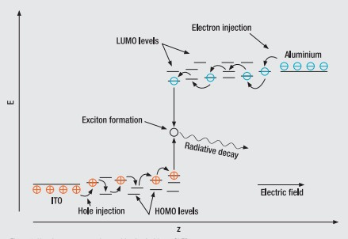

**Figure 3:** Energy Level diagram

As electrons and holes are [fermions](https://en.wikipedia.org/wiki/Fermion) with half integer [spin](https://en.wikipedia.org/wiki/Spin_(physics)), an exciton may either be in a [singlet state](https://en.wikipedia.org/wiki/Singlet_state) or a [triplet state](https://en.wikipedia.org/wiki/Triplet_state) depending on how the spins of the electron and hole have been combined. Statistically three triplet excitons will be formed for each singlet exciton. Decay from triplet states ([phosphorescence](https://en.wikipedia.org/wiki/Phosphorescence)) is spin forbidden, increasing the timescale of the transition and limiting the internal efficiency of fluorescent devices. [Phosphorescent organic](https://en.wikipedia.org/wiki/Phosphorescent_organic_light-emitting_diode) [light-emitting diodes](https://en.wikipedia.org/wiki/Phosphorescent_organic_light-emitting_diode) make use of [spin–orbit interactions](https://en.wikipedia.org/wiki/Spin%E2%80%93orbit_interaction) to facilitate [intersystem](https://en.wikipedia.org/wiki/Intersystem_crossing) [crossing](https://en.wikipedia.org/wiki/Intersystem_crossing) between singlet and triplet states, thus obtaining emission from both singlet and triplet states and improving the internal efficiency.

[Indium tin oxide](https://en.wikipedia.org/wiki/Indium_tin_oxide) (ITO) is commonly used as the anode material. It is transparent to visible light and has a high [work function](https://en.wikipedia.org/wiki/Work_function) which promotes injection of holes into the HOMO level of the organic layer. A typical conductive layer may consist of PEDOT:PSS as the HOMO level of this material generally lies between the work function of ITO and the HOMO of other commonly used polymers, reducing the energy barriers for hole injection. Metals such as [barium](https://en.wikipedia.org/wiki/Barium) and [calcium](https://en.wikipedia.org/wiki/Calcium) are often used for the cathode as they have low [work functions](https://en.wikipedia.org/wiki/Work_function) which promote injection of electrons into the LUMO of the organic layer. Such metals are reactive, so they require a capping layer of [aluminum](https://en.wikipedia.org/wiki/Aluminium) to avoid degradation.

Experimental research has proven that the properties of the anode, specifically the anode/hole transport layer (HTL) interface topography plays a major role in the efficiency, performance, and lifetime of organic light emitting diodes. Imperfections in the surface of the anode decrease anode-organic film interface adhesion, increase electrical resistance, and allow for more frequent formation of non-emissive dark spots in the OLED material adversely affecting lifetime. Mechanisms to decrease anode roughness for ITO/glass substrates include the use of thin films and self-assembled monolayers. Also, alternative substrates and anode materials are being considered to increase OLED performance and lifetime. Possible examples include single crystal sapphire substrates treated with gold (Au) film anodes yielding lower work functions, operating voltages, electrical resistance values, and increasing lifetime of OLEDs.

Single carrier devices are typically used to study the [kinetics](https://en.wikipedia.org/wiki/Chemical_kinetics) and charge transport mechanisms of an organic material and can be useful when trying to study energy transfer processes. As current through the device is composed of only one type of charge carrier, either electrons or holes, recombination does not occur and no light is emitted. For example,

electron only devices can be obtained by replacing ITO with a lower work function metal which increases the energy barrier of hole injection. Similarly, hole only devices can be made by using a cathode made solely of aluminum, resulting in an energy barrier too large for efficient electron injection.

1. **Emission spectrum**

Typical emission spectra of organic molecules are broad (as shown in figure X). As stated before, the emission color is a material property. Thus, the total emission can be tuned to virtually any color, including white at any color temperature, by stacking several different emitting layers in a single device. This is possible since the organic layers are almost transparent in the visible spectral range. Most white OLEDs contain a red, a green and a blue emission layer to create high-quality white light.

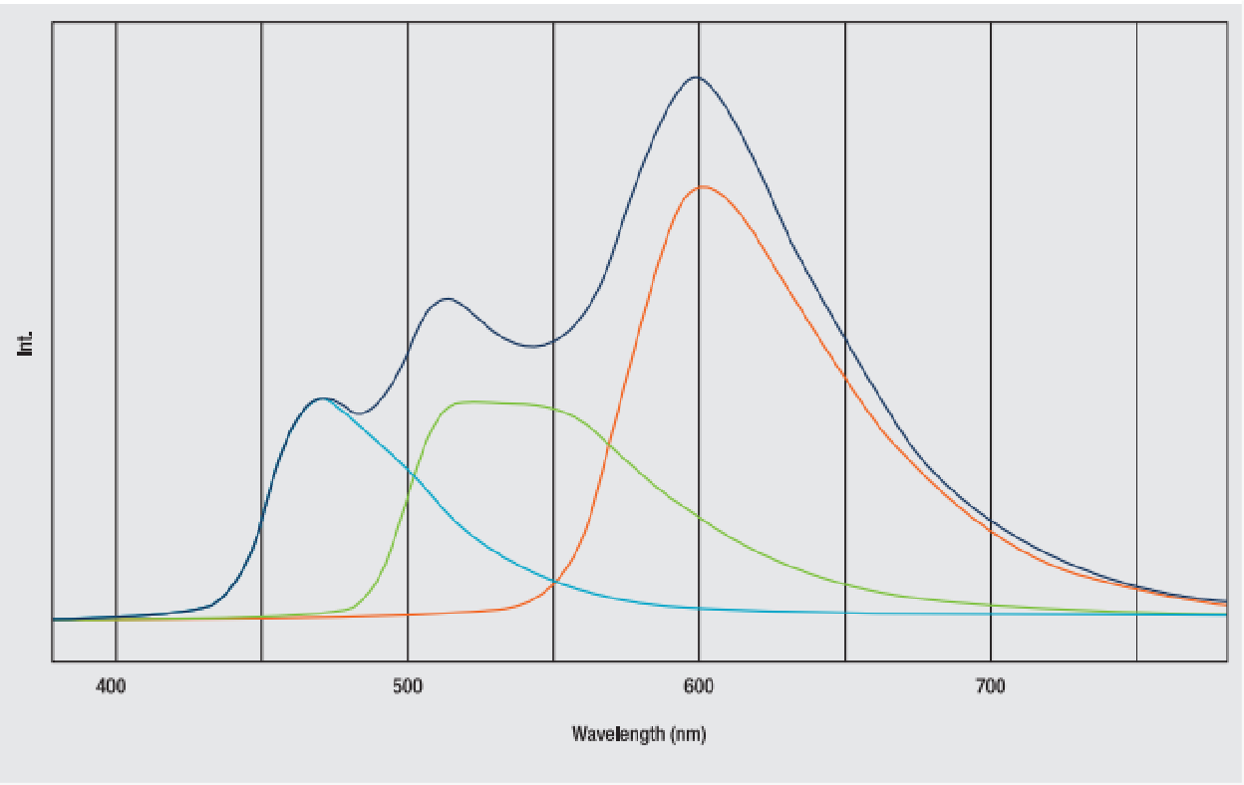

**Figure 4:** Typical emission spectra of organic materials.

The diagram shows spectra of red, green and blue emitters and their superposition which yields white emission at a high color rendering index.

## OLED Architectures

* + **Bottom or top emission**

Bottom or top distinction refers not to orientation of the OLED display, but to the direction that emitted light exits the device. OLED devices are classified as bottom emission devices if light emitted passes through the transparent or semi-transparent bottom electrode and substrate on which the panel was manufactured. Top emission devices are classified based on whether or not the light emitted from the OLED device exits through the lid that is added following fabrication of the device. Top-emitting OLEDs are better suited for active-matrix applications as they can be more easily integrated with a non-transparent transistor backplane. The TFT array attached to the bottom substrate on which AMOLEDs are manufactured are typically non- transparent, resulting in considerable blockage of transmitted light if the device followed a bottom emitting scheme.[[53]](https://en.wikipedia.org/wiki/OLED#cite_note-53)

## Transparent OLEDs

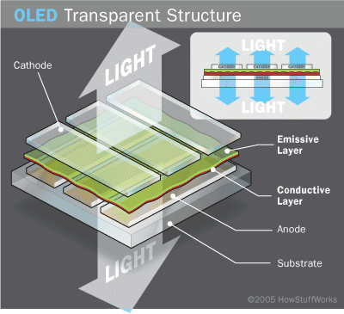Transparent OLEDs use transparent or semi-transparent contacts on both sides of the device to create displays that can be made to be both top and bottom emitting (transparent). TOLEDs can greatly improve contrast, making it much easier to view displays in bright sunlight. This technology can be used in [Head-up displays](https://en.wikipedia.org/wiki/Head-up_display), smart windows or [augmented reality](https://en.wikipedia.org/wiki/Augmented_reality) applications.

**Figure 5:** Transparent OLED structure

## Graded Heterojunction

Graded hetero junction OLEDs gradually decrease the ratio of electron holes to electron transporting chemicals. This results in almost double the quantum efficiency of existing OLEDs.

## Stacked OLEDs

Stacked OLEDs use a pixel architecture that stacks the red, green, and blue sub pixels on top of one another instead of next to one another, leading to substantial increase in [gamut](https://en.wikipedia.org/wiki/Gamut) and color depth, and greatly reducing pixel gap. Currently, other display technologies have the RGB (and RGBW) pixels mapped next to each other decreasing potential resolution.

## Inverted OLED

In contrast to a conventional OLED, in which the anode is placed on the substrate, an Inverted OLED uses a bottom cathode that can be connected to the drain end of an n- channel TFT especially for the low cost [amorphous silicon](https://en.wikipedia.org/wiki/Amorphous_silicon) TFT backplane useful in the manufacturing of [AMOLED](https://en.wikipedia.org/wiki/AMOLED) displays.

## Manufacturing OLED

The technological process of manufacturing OLEDs does not have fundamental differences. In all cases, the process involves four basic steps: preparation of the substrate with the anode layer, applying polymer layers, applying cathode layer and encapsulation, i.e. coating the device with dense chemical resistant material layer, or gluing between glass plates to isolate from the surrounding atmosphere. This method allows to greatly increasing the lifetime of the device, which is critical for industrial designs. In the production of model devices intended for research purposes, the last stage is often omitted, since the encapsulation does not affect the basic operating characteristics of the OLED (except for the duration of the operation), but considerably complicates the process. Significant differences from the mentioned schemes have roll technology, which promising for making large luminous surfaces.

## Fabrication Methods

There are two main methods of fabricating the OLED devices, which differ in the method of applying nanolayers of polymer materials: a method of evaporation-condensation of material in a vacuum, and the method of coating layers of solutions. In both cases, deposition of the metallic cathode layer is nearly always carried out by evaporation in a vacuum.

Mandatory and an important step in the fabrication of OLEDs, regardless of the method, is the step of preparing the substrate surface. Insufficient clarity causes to the low efficiency, or complete absence of luminescence even using efficient fluorescent materials. In most cases, the substrate is a glass plate covered with a layer of ITO, i.e. the surface of this particular layer is subjected to the treatment. Sufficiently clean surface provides a primary rinsing sample in distilled water with containing detergents, mechanical cleaning, followed by washing with deionized water and then with isopropyl alcohol in an ultrasonic bath. Good results are obtained by subsequent irradiation with UV simultaneously treated the surface with ozone. In this case, not only additional cleaning is achieved, but improved hole injection properties of the ITO layer.

## Physical vapor deposition

When evaporation-condensation method is used, the polymer layers of the device formed by evaporating material with a thermal resistive evaporator at high vacuum (at least 5 • 10-4 Pa) and its condensation on the substrate installed above the evaporator at a distance of 10-20 cm.

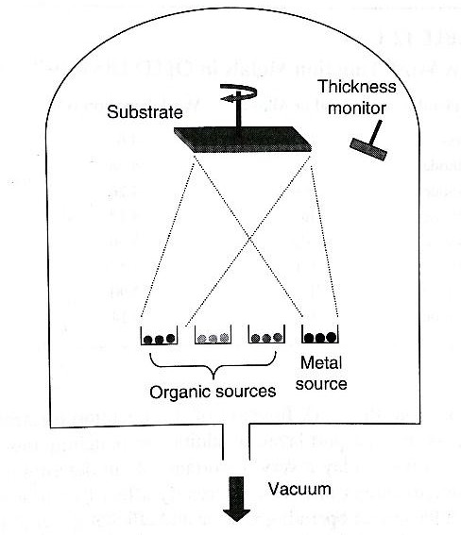

**Figure 6:** Physical Vapor Deposition (PVD) in vacuum chamber

The method of vacuum evaporation-condensation has significant limitations. The main limitation is substances, that have to be capable to sublime without decomposition, i.e. having sufficient volatility and thermal stability. This dramatically reduces the number of potential electro luminous.

When using small molecule layers, evaporative techniques are commonly chosen. The small molecules are evaporated in a vacuum chamber onto a substrate and form a thin layer. Another method is called chemical vapor deposition (CVD). In CVD, a substrate is placed in a vacuum and a chemical is introduced causing the film to condense onto the substrate. A disadvantage of this method is that everything inside the vacuum will get coated, leading to waste of material. [1]

## Spin coating

In spin- coating method the organic materials are deposited in liquid form.To obtain uniform layers in designing laboratory samples special centrifuges are used, which allow changing the acceleration, speed, and duration of rotation. The substrate is mounted in the center of the centrifuge and one or more drops of solution are dropped on it. The substrate is rotated at high speed causing the liquid to spread out and dry. The liquid will uniform thin solid layer of dissolved compounds.

The thickness of the layer is determined by the amount of rotating time and the drying rate of the material. Films produced this way tend to have an inconsistent thickness as well as poor surface smoothness.

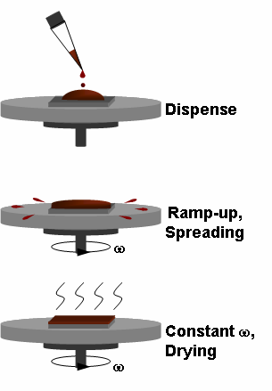

**Figure 7:** In Spin coating, a drop of the material is deposited onto a substrate and rotated at high speed until it spreads to the desired thickness.

## Ink Jet Printing

Ink jet technology has many advantages in comparison with photolithography. Since, it is used much a small volume of material, and the process is "dry", i.e. there is no air pollution harmful liquids. In addition, the manufacturing process consists of fewer steps. This technology is best suites for multi-layer structures since the interlayer connection can be directly applied to the substrate. Thus, ink jet printing allows making multilayer OLED, which has a low cost, and without any harm to the environment. Two kinds of ink used in the process of manufacturing multilayer structures by ink jet printing - conductive and insulating. In other methods of ink jet printing is used heated colorant with a very high temperature before being discharged, which is not suitable for printing polymer materials.

To get the necessary precision in display manufacturing, at first micro-grooves are made on a substrate by photolithography. Then they are filled (printed by technological jet printer) in series red, blue, and green polymer, forming the structure of the RGB-subpixels. Electronics of display combines every three sub-pixels in one full-color pixel. This method provides a pixel pitch of 128 microns with the size of each sub-pixel 40 microns. To improve the clarity of the print OLEDs, used another technological trick. Grooves on the substrate are covered with a hydrophilic material, and the surface between them - hydrophobic. These substances respectively attract or repel the polymer solution, providing the required printing accuracy. All the microdroplets of liquid polymer falling into the grooves with minimum smearing the polymer on barier layer. In the industrial production the solutions are applied to the substrate in the form of dots by devices such ink jet printers.

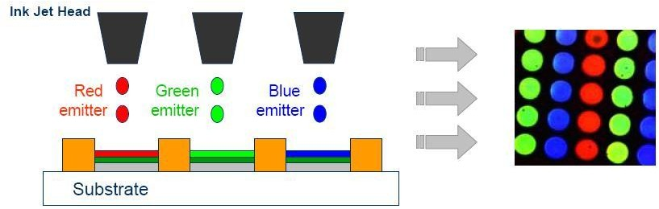

**Figure 8:** Ink jet printing to pattern polymers (Full Color Applications)

## Roll to roll Printing (R2R)

Method of ink jet printing and using a polymer base allows producing flexible, large area luminous panel, but this technology has number of limitations related with protection of polymer layers from the environment. Roll printing (lamination technology) allows to solve these problems and improve OLED performance. The key point of this method is using two components of panel - an anode and a cathode, which each of them is prepared individually in the preliminary stage of the process. The cathode material is a polymer film or metal foil with deposited cathode, electron injection and emission layers. The anode material is a polymer film deposited with anode and hole transport layers. Then two components are combined to form a multi-layered OLED flexible material

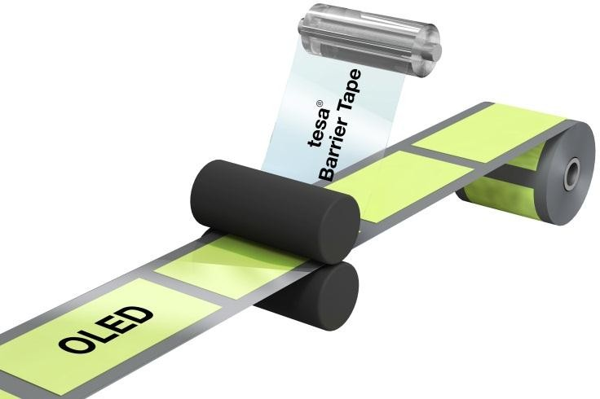

**Figure 9:** Roll to roll printing production of flexible OLED’ s

## Vacuum sputtering

In the production of full-color OLED-panels an active matrix are used as the base, on which polymer layers sputter. Each element (pixel) is an independent OLED-cell containing a controling field tranzistor OFET. There are two types of facilities for industrial production - with radial and linear arrangement of chambers for the preparation of the substrate, the application of the polymer layers, cathode and encapsulation.

In a linear arrangement all cameras are disposed in series, which allows to assemble panels in a continuous mode. Most industrial facilities, providing high quality products with high performance, combined radial and linear sections.

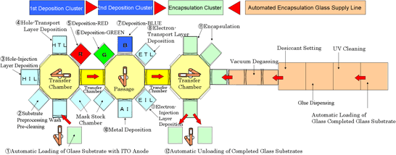

**Figure 10:** OLED mass production system

## Technical Characteristics

To evaluate the efficiency of the OLED more than 10 parameters is used. For some of them have not worked out the exact criteria that must be considered when comparing the characteristics of the LEDs.

|  |  |
| --- | --- |
| Energy Efficiency | 180 lm/Wt |
| Сurrent Efficiency | 40 cd/A |
| Internal Quantum Efficiency (Exiton/Photon) | 100% |
| External Quantum Efficiency (Illuminated photon/Formed photon) | 40% |
| Opearting Voltage | 5 - 8 V |
| Inclusion Voltage | 3 - 9 V |
| Angle of View | 180° |
| Brightness | 1000 cd/m² |
| Contrast | 100:1 |
| Life Time | 6 - 11 years |
| Temperature Range | -40…+50 oC |

**Table 1:** Technical Characteristics of OLED’s

## Types of OLED

There 6 different types of OLED available at the moment and all of them are designed for a different aim. Types are the below:

* + Passive Matrix OLEDs (PMOLEDs): They have strips of cathode, organic layers and stripes of anode. Anode and cathode stripes are placed perpendicular each other. Pixels are generated at the region where cathode and anode are intersected with the emitted light. A current is applied to some strips of cathode and anode to determine pixels whether on or off. Also this amount of this current affects the brightness. Although this type of OLED is easy to produce; compared to others, they consume more power which is because of the supplied current. However power consumption is still less than LCDs and they are suitable for text or icon based small screens around 2-3 inches. For instance, some cell phones and MP3 players have this type of OLEDs.
  + Active Matrix OLEDs (AMOLEDs): They have full layers of cathode, organic molecules and anode. However there is a thin film transistor (TFT) which forms a matrix on the anode layer. This array sets pixels on or off to generate an image. This type consumes power less than PMOLEDs just because TFT array therefore AMOLEDs are preferred in large displays. Large screen TV’s, monitors and billboards are some products that this type is used.

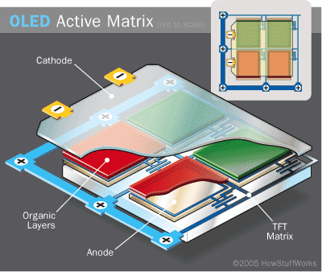

**Figure 11:** AMOLED.

* + Top-emitting OLEDs: They have opaque or reflective substrates. They have mostly active matrix design since it fits best. This type is used in smart cards.

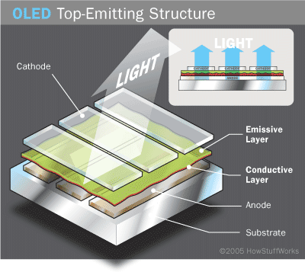

**Figure 12:** Top-Emitting OLED Structure

* + Foldable OLEDs: Very flexible metallic foils or plastics are used on the substrate of foldable OLEDs. They are very light and strong. They are used in cell phones thus products will be stronger for breakage issues. Other areas that this type used can be integrated computer chips and GPS devices.

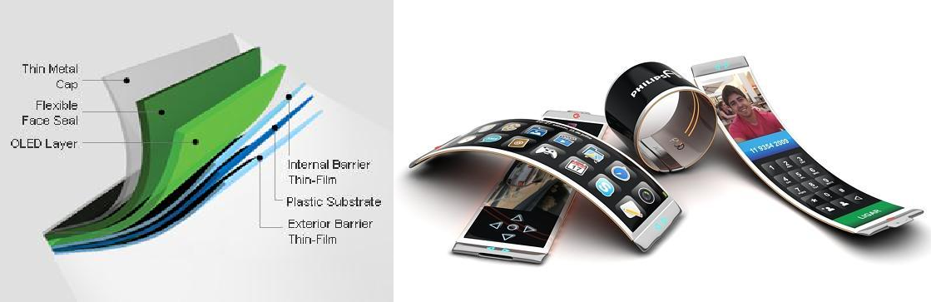

**Figure 13:** Foldable OLED

* + White OLEDs: White light is emitted in this type and it generates a brighter light. Also it is more uniform and more energy efficient than regular fluorescent lights. This type has the true-color characteristics of incandescent lighting. Therefore it is possible to be replaced with fluorescent lights that we currently use because of the economy OLEDs provide.

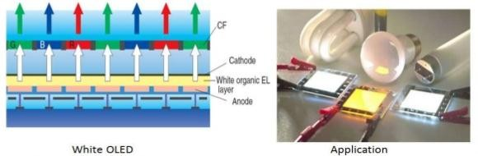

**Figure 14:** White OLED

## Comparison Between LED and OLED

Although OLED name has been heard much more recently, it is not a new terminology in the technology world. In the beginning of 2000s, we used them in mobile phone screens. However LED took place much more in daily life afterwards. Technically, OLEDs emit light but LEDs diffuse or reflect and this seems the main difference between these two light sources.

What is LED? : **Light-emitting diode** is one of the widely used and known light sources these days. But its history is about a solid state device that makes light with the help of electrons through a semi-conductor. Also this type is smaller than some other sources such as compact fluorescent and incandescent light bulbs. However it provides higher brightness than its rivals. Although it has some advantages in this area, it is not enough to be used as a pixel of the television just because of its size. Therefore it became popular in lighting industry.

What is OLED? : **Organic light-emitting diode** includes some organic compounds that light when electricity supplied. There is not much difference about architecture between LED and OLED but being thin, small and flexible are the main advantages of OLEDs. Also each pixel on OLED televisions works individually.

As can be seen from the definitions of LED and OLED, they have some differences and these strongly affect the quality of the end product. For instance, backlight is used to illuminate their pixels in LED but pixels produce their own light in OLED. OLED’s pixels called emissive. Therefore OLEDs provide the flexibility of brightness control through pixel by

pixel changes. Tests of a LED display in dark conditions show that parts of an image are not perfectly black because backlight is showed through.

The great advantage for LEDs looks about economy since its production costs are much cheaper. However after OLED market is developed, it is predicted that the difference will be made up. Production of an OLED is easier and it is possible to produce it in larger sizes. Its content plays the main role for this because plastic is a suitable material for this but it is harder to do it with liquid crystals.

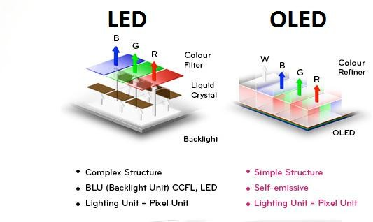

**Figure 15:** Comparison of LED and OLED

At the moment, OLED TVs provide a wider viewing range around 170 degrees because it produces its own light. Since it is open to development, OLED is quite appropriate tool for TV and monitor industry. Plastic and organic layers in OLED are thinner than inorganic crystal layers in LED, brighter light is generated. Additionally, it is required to support LED with glass and this absorbs some of the light as well however there is no such a need in OLED.

At the moment, OLED TVs provide a wider viewing range around 170 degrees because it produces its own light. Since it is open to development, OLED is quite appropriate tool for TV and monitor industry. Plastic and organic layers in OLED are thinner than inorganic crystal layers in LED, brighter light is generated. Additionally, it is required to support LED with glass and this absorbs some of the light as well however there is no such a need in OLED.

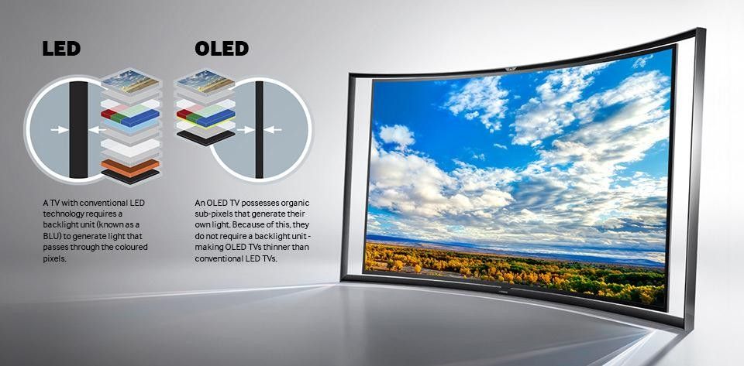

**Figure 16:** Comparison of LED and OLED Display

## Advantages of OLED

1. OLED’s are biodegradable.
2. OLED’s are thinner, lighter and more flexible compared to the crystalline layers in LCD’s or LED’s.
3. OLED’s are flexible, they can be folded and rolled up as in the case of roll-up displays embedded in textiles. This is because the substrate used in OLED is plastic rather than the glass used for an LCD or an LED.
4. OLED’s are brighter than LEDs. They have greater artificial contrast ratio as shown in figure 17. Because the organic layers of an OLED is much thinner than the corresponding inorganic crystal layers of an LED, the conductive and emissive layers of an OLED can be multi-layered and does not require glass which absorbs some part of light.

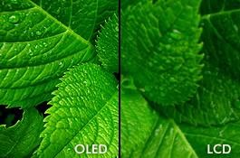 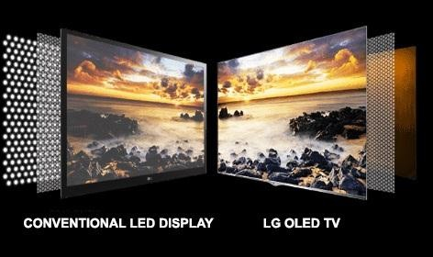

**Figure 17:** Comparison of LCD, LED and OLED displays

1. An OLED does not require backlight as in the case of an LCD as shown in above figure 17. This in turn reduces the power consumption by an OLED. LCD’s requires illumination to produce visible image which requires more power, whereas OLED’s generate its own light.
2. Process of producing an OLED is easier and it can be made into large thin sheets. It is much more difficult to grow so many liquid crystal layers.
3. OLED’s have wider viewing angles compared to LCD’s as an OLED pixel emits light directly. OLED pixel colors are not shifted as we change the angle of observation to 90° from normal.
4. An OLED has much faster response time compared to an LCD.

## Disadvantages:

1. Lifespan: Lifetime of an OLED is lesser than LCD. Red and green OLED films have longer lifetimes (46,000 to 230,000 hours), blue OLED’s currently have much shorter lifetimes (up to around 14,000 hours)[3].
2. Material used in OLED to produce blue light degrades faster than materials producing other colors this causes reduction of overall luminescence.
3. Interaction of OLED with water causes instant damage.
4. OLED uses three times more power to display an image with white background, usage of white background leads to reduced battery life in mobile devices.

## Applications of OLED:

OLED’s are currently being used in developing small screen devices such as cell phones, PDA’s, DVD players and digital cameras. Its ability to be foldable and flexible makes it weight and space saving technology. Some of the applications are as shown in figure 18. In March 2003, Kodak released a first digital camera using OLED display[4].

Several companies have prototypes for built in Monitors and TV screens that use OLED technology. Nokia has come up with the concept of scroll laptop. The Fraunhofer Institute has created a miniaturized OLED display with SVGA (600x800) resolution measuring just 0.6-inches diagonal. That provides a pixel density of 1,667 pixels-per-inch. Applications of OLED’s are being continuously expanding.

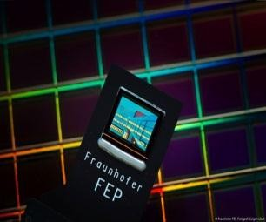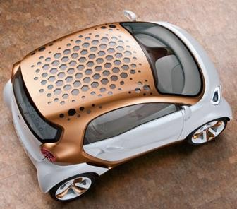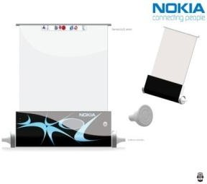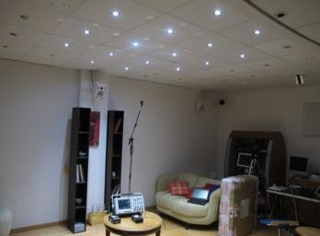

**Figure 18:** Applications of OLED

OLED’s are also used in multiple-input/multiple-output (MIMO) wireless optical channels. OLED’s are emissive transmitters printed on flexible sheets of plastic. High transmission speed of OLED’s can be used in visible optical communications. The communication field is limited near the emitting area of an OLED, resulting in a safe data transmission.

## Challenges

OLED’s has many applications, but it is important to consider some of the problems involved. Below are some of the challenges we need to face when we consider OLED’s:

1. Expensive (~10/20 times costlier than the same performing LED)
2. Lack of wide range of commercially available products Communication aspect:
3. Light efficiency is low
4. High capacitance thus limiting the device modulation bandwidth (100’s kHz)

## Future Possibilities

Achieving higher data rate, such as 10-15 Mbit/s, so that OLED can be adopted in standard 10BASE-T Ethernet communications. Working with the manufacturers to improve the device response time (newer display has faster response and wider dynamic contrast range). The newspaper of the future might be an OLED display automotive dashboards, billboard-type displays, home and office lighting.

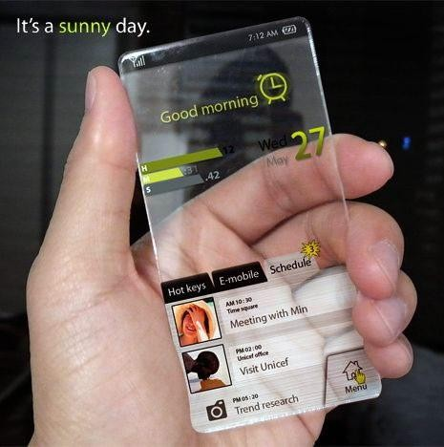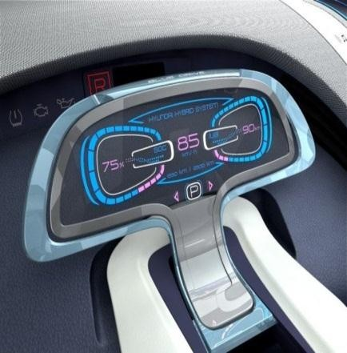

**Figure 19:** Future Possibilities of OLED

## Conclusion:

A great progress has been made in the field of organic electronics and devices in terms of synthesis, development and applications of electron transport materials to improve the performance of OLED’s. The effectiveness of the OLED device is governed by three important processes: charge injection, charge transport and emission. Light emission through phosphorescent dyes has been utilized in OLEDs and gives good results. OLEDs have achieved long operational stability. The performance of OLEDs meets many of the targets necessary for applications in displays.

Research and development in the field of OLEDs is proceeding rapidly and may lead to future applications in heads-up displays, automotive dashboards, billboard-type displays, home and office lighting and flexible displays. OLEDs refresh faster than LCDs (almost 1,000 times faster). A device with an OLED display changes information almost in real time. Video images could be much more realistic and constantly updated. The newspaper of the future might be an OLED display that refreshes with breaking news and like a regular newspaper, you could fold it up when you're done reading it and stick it in your backpack or briefcase.

## References:

1. https:/[/www.ukessa](http://www.ukessays.com/essays/engineering/advantages-and-disadvantages-of-organic-)y[s.com/essays/engineering/advantages-and-disadvantages-of-organic-](http://www.ukessays.com/essays/engineering/advantages-and-disadvantages-of-organic-) light-emitting-diodes-engineering-essay.php , Published: 23, March 2015
2. <http://electronics.howstuffworks.com/oled6.htm>
3. “Introduction and basic OLED Information”, Available Online at: [http://www.oled-](http://www.oled-info.com/introduction) [info.com/introduction](http://www.oled-info.com/introduction)
4. Dr. Craig Freundenrich, “Current and Future OLED Applications”
5. Steve Hranilovic, “Wireless Optical Communication Systems”, Springer publications, 2005 Edition.
6. Ghassan E. Jabbour et al., Screen Printing for the Fabrication of Organic Light-Emitting Devices, IEEE 7:5, 2001
7. OLED Fabrication for Use in Display Systems / Chris Summitt / 06.12.2006